Contents

A i 1

Executive Overview 1

**Assumptions** 2

**Research** 2

**Emerging tech** 3

**How it will help user needs** 5

**Industry guidelines** 6

Activity A ii 7

**My proposal** 7

**Functional Requirments** 7

**Non-Functional Requirements** 8

**Decomposition of problems** 9

**Buisess context** 9

**Feasability** **Error! Bookmark not defined.**

**Key performace indicators / User acceptance** 11

**How my solution meets the requirements and user needs** 12

**How potential risk will be delt with** 12

**How relevant regulatory guidelines and legal requirements in relation to software development and the industy will be adressed** 13

# A i

# Executive Overview

A software company has asked me to develop a digital solution for Toka Fitness.

**Toka Fitness currently provides customers with:**

* Personal training sessions
* Advice about fitness training
* Advice about healthy living

**The client would like me to develop a digital solution that will:**

* provide information and advice about fitness training and healthy living
* provide access to digital content to support customers with their training and healthy lifestyle
* encourage existing customers to use more of the services provided by toka fitness.

**The client has carried out some market reasearch with existing cutomers, to identify features that could be included in the digital solution. The potential features suggested by the existing customers are:**

* Free and paid-for content
* Accessibility features for users with sight loss
* ‘Social’ features such as a forum page
* Customisable workout and eating plans

# **Assumptions**

* **I have made the assumption that once i have created the website locally it will then need to be put on a domain that the company will need to provide later on so new and existing customers may acsess the website to its full.**
* **I have also made the assumption that Toka Fitness is a physical gym and have the facilities to enhouse the required equipment they may need physically. By having a physical location Toka can be provided feedback within the gym and online through the website.**

# **Research**

**How Technology Can Help Fitness**

Becuase of technology people are able to share and communicate with each other, directly or indirectly, bout heir fitness goals, aspirations, fustrations and achievements.

There are many various types and styles of fitness inspiration accounts to follow. For starters, certain fitness-related businesses and enterprises hold fitness accounts. They encourage netizens to live a healthy and active lifestyle while also inviting them to use their services. Second, there are fitness accounts held by personal trainers and freelance fitness experts. They provide general advice and respond to key concerns by posting recommendations and advice. Finally, there are social media stars that aren't necessarily fitness professionals but serve as fitness role models for others.

**Videos**

The internet is full of videos of people showing you how to do certain exercises or guiding you through workout routines and much more, Videos can really benefit your exercise routine as it is all acsessible to watch anywhere using smartphones or any device.

**Health Advice**

Certian application and devices are capable of monitoing excersise, heartrate,calories intake/burn. this is certainly usefull for a company/buisness, as you can track how well your customers are doing, can help with chosing which plan is right for then.

This data can provide accurate insight about your current standing on fitness journey. Some options also provide behavioral feedback and can act as reinforcers to help reach particular goals.

# **Emerging tech**

**Hardware**

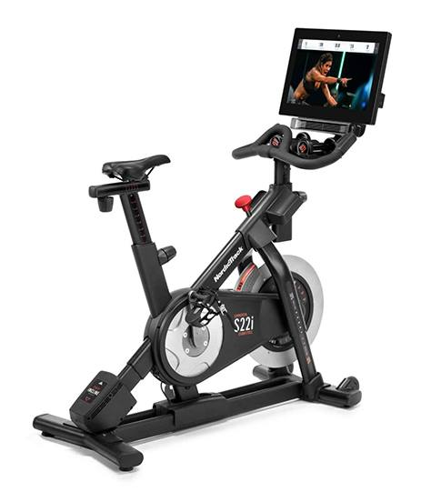With the help of technology a simple tredmill can be turned into a state of the art fitness wonder, with integrated TV scren and heart-rate monitors are now an essential compent of a tradmill; even more so newly emerging fitness bikes can come with built in screen, allowing a more emmersive experience whilst excersing, ranging from scenic locations to bike through, acsessible application that can monitor how many calories you burn, distance travelled and much more, most of the new bikes come with a built in personal trainer right at your finger tips, encouraging you as you workout.

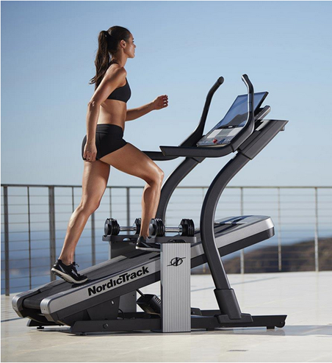

Smart watches, treadmills, rowing machines, and other fitness gadgets are among the most common. Hardware is advantageous because, unlike software, it necessitates the need of a human to perform any of the actions. Smart watches, for example, may track heart rate, calories burned, steps taken, kilometres traveled, and more.

**Software**

**Apple Health**

With the latest iPhone IOS, this is how Apple's Health app looks. It appears to be very clean and user-friendly. Apple Health is only compatible with IOS devices (Apple products) and may connect to other Apple products such as Apple watches, phones, and other accessories. I have a review of the product and what people liked and hated about it, as well as app store reviews. The bibliography is at the bottom of the page.

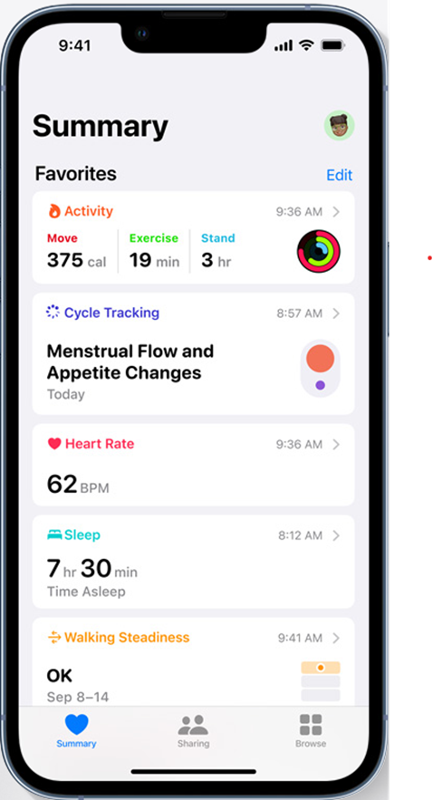

How long user has slept for

Heart rate monitor, shows beats per min

How long user has excersised, how long they did it for and how many calories burned and

A lot of the data can be better recorded from the watch like; burnt calories, steps walked, how many flights of stairs, and more. the GUI of the watch Is different but still looks very professional.

# **How it will help user needs**

**whilst conducting my research i have noticed that a forum page or some kind of webpage that allows users to communicate and leave feedback would meet the one of the needs asked by the company.**

**The forum page could also help with providing information about fitness from third-party users or users with a Toka Membership.**

**Do make the forum page i have decided to use PHP which will easily allow me to create a space where users can create an account, comment and read about fitness and healthy living.**

**By using smart watches or any device capable of smart fitness, the company can monitor how much** excersise a user may be doing not only at the gym but at home, this can have a massive effect on customer interactions and can play a huge part in deciding what areas to work on or to set a customised workout plan for the user.

**Advantages**

**Fitness technology is not only beneficial for fitness freaks, but it is also helping trainers. Along with them, it is putting a great impact on the fitness industry and business and taking it towards its peak**

**The long run of the fitness trade is hybrid, one that connects the most effective of each digital and physical world.**

**Some users may feel motivated whilst using a fitness tracker as it gives a good visual representation of your progress and gives good motivation to improve and do more and more each day.**

**Disadvantages**

Whilst the advantages of using fitness technonogy may seem substatial there are some drawbacks such as:

* Expense
  + Fitness trackers can be expensive to buy. If you don’t use it, you could have spent your money on something more useful.
* Battery
  + Most trackers have limited battery life. When charging your device, you will not be able to keep track of your steps or workouts.
* Accuracy
  + Some trackers do not provide 100% accurate metrics/information that may be shown on the device. Some of that information is just an estimate. Try not to fully rely on these devices.

# **Industry guidelines**

**• GDPR (General Data Protection Regulation)**

**• Computer Misuse Act 1990.**

**GDPR**

When storing users personal data as a company we must ensure that we have proved that the user has concented to the company sotring their data as we must follow **GDPR**.

As a company we must ensure that we do not keep the users data any longer than it is needed, for example if the user decides to delete their account we must ensure that all their stored data is deleted as well.

We must also regularly review our information and erase or anonymise personal data when we no longer need it.

**Computer Misuse Act**

The Computer Misuse Act 1990 protects personal data held by organisations from unauthorised access and modification). The act makes the following illegal:

Unauthorised access to computer material. This refers to entering a computer system without permission (hacking)

1. Unauthorised access to computer materials with intent to commit a further crime. This refers to entering a computer system to steal data or destroy a device or network (such as planting a virus)

2. Unauthorised modification of data. This refers to modifying or deleting data, and also covers the introduction of malware or spyware onto a computer (electronic vandalism and theft of information)

3. Making, supplying, or obtaining anything which can be used in computer misuse offences

These four clauses cover a range of offences including hacking, computer fraud, blackmail, and viruses. Failure to comply with the Computer Misuse Act can lead to fines and potentially imprisonment. (BBC, n.d.)

# Activity A ii

# **My proposal**

My proposed solution will be to create a website that will allow the user to create and account to acsess the website further. There will be a free account that will be able to acsess some of the lower teir content of the website, and a premiem account (paid) which will have full acsess to the website such as acsess to customasible workout and eating plans and much more.

* To make the website i will be coding in HTML and JavaScript to impliment some dynamic features on the page.

When creating an account i will be using mySQL to store the account details on a database where it will be easily acsessible and secured.

I also plan to add a social tab/forum page to the website allowing users to write reviews and communicatie with each about how they are getting on with their goals and to discuss their fustrations and how to improve and reach new goals.

* To do the forum page i will be using PHP which will allow me to make the page.

# **Functional Requirments**

|  |  |  |  |  |
| --- | --- | --- | --- | --- |
| **Function**  **Requirements** | **User Requirements** | **Req #** | **How will I accomplish** | **Acceptance** |
| **Data is stored in database once user is created** | **as a user when i create and account i want it stored in a database** | **1** | **User creates account** |  |
|  |  | **2** | **Data from user creating account stored in database using SQL** |  |
| **Premium members will have acsess to forum page and be able to leave comments** | **as a user[premium] i want to be able to acsess and leave comments on a forum page** | **1** |  |  |
|  |  | **2** |  |  |
|  |  | **3** |  |  |
| **Data is stored in database once user is created** | **as a company i want a database where user information will be stored** | **1** | **Using SQL i will create a data base** |  |
|  |  | **2** |  |  |
|  |  | **3** |  |  |
| **Create useable website** | **Basic website** | **1** | **Using HTML and JavaScript i will make a website** | **When i click load on the website it will open and allow me to access the website as a whole** |
|  | **Allow login/authentication** | **2** |  |  |
|  |  |  |  |  |

**Justification**

|  |  |  |
| --- | --- | --- |
| **Requirements** | **How will I accomplish** | **Acceptance** |
| **Create useable website** | **Using HTML and JavaScript i will make a website** | **When i click load on the website it will open and allow me to access the website as a whole** |
|  |  |  |

# **Non-Functional Requirements**

**• The program can run.**

**• The program loads every time.**

**• Updated quickly.**

**• The program runs effectively.**

**• It performs well under stress.**

**• Updated security to protect users.**

**• No bugs/errors or very little on release.**

# **Decomposition of problems**

**Problem 1 – make a system that can Provided information to the user about fitness training and healthy living**

**• Provide information.**

**• Store information.**

**• Save it in a suitable way.**

**• Fetch information.**

**• Display information.**

# **Business context**

* **risk assessment**

**Can the project be completed within the time frame?**

**I believe that the project can be completed within the time frame, however if a staff member or my self became unable to work then the project may fall behind schedule and will most likely have to be delayed**

**I recommend using a Ghant chart to keep a tight time schedule so everybody knows what they should be working on and when.**

**As a company do we have the resources to complete the project?**

**I believe that the company does have enough resources, such as money, time, software needed for development.**

**However, if there is something else needed, such as a new software or a new member of staff with a required set of skills then the company will have to provide it if not you may run the risk of not being able to complete the project**

**Is there enough staff with the required skill?**

**Some areas of the project may require certain skills such as a difficult programming language to code within and will require a member of staff with expertise in that area, hiring someone with desired skills tend to be expensive.**

**If certain skills are not met the productivity of the project may slow as a member of staff will have to stop working on what they were doing and learn the new language and may have to adjust and adapt to their new environment**

**As a company is there any licensing for software or any legal obstacles?**

**As a company you may face some legal obstacles, such as copyright infringement**

**this could set the project back due to its nature and will most likely put the project on a hold once the company has proven that they have not copied or plagiarised any work they may resume the project.**

**Another legal problem the company may face is how many hours a week a member of staff is working, due to the time frame a manager may try to enforce that staff works longer hours. However if a member if staff works over 48hours a week the company could face lawsuits.**

**When it comes to licensing it can be very expensive to provide a licence to each member of staff or to those who may need it, meaning if the company is tight on budget and cannot provide enough licences there may well in truly be a large delay, as some staff will have to share a licence reducing productivity.**

# **Feasibility**

**Executive Summary**

**The client would like me to develop a digital solution that will:**

* provide information and advice about fitness training and healthy living
* provide access to digital content to support customers with their training and healthy lifestyle
* encourage existing customers to use more of the services provided by toka fitness.

**The client has carried out some market research with existing customers, to identify features that could be included in the digital solution. The potential features suggested by the existing customers are:**

* Free and paid-for content
* Accessibility features for users with sight loss
* ‘Social’ features such as a forum page
* Customisable workout and eating plans

**Evaluation of Solutions**

**My proposed solution will be to create a website that will allow the user to create and account to access the website further.**

**•To make the website i will be coding in HTML and JavaScript to implement some dynamic features on the page.**

**When creating an account I will be using mySQL to store the account details on a database where it will be easily accessible and secured.**

**Is this project feasible?**

**Personally I do think this project is feasible,**

**Following my proposed plan and by ensuring that I have enough time to add all the features I intend to add, i will be heavily sticking to a Ghantchart or a similar sprint system to ensure that I can meet the required deadline.**

**Using the sprint system i can easily get the required functional elements implemented then start working and further developing and improving what is already there.**

**From that point on i can really home in on the design of the webpage.**

**Given that the time restraint is 30hours I do think this project will be manageable within that said deadline.**

**Funding wise I think the project would not cost too much to build or maintain, by following through with this project I can see a strong outcome that would not only boost the customer’s experience but could improve the company as a whole, due to the interactivity and inclusivity of the new website.**

# **Key performance indicators / User acceptance**

|  |  |  |
| --- | --- | --- |
| **Row #** | **Task to perform.** | **User acceptance criteria.** |
| **1** | **Create software that can send information to the user about fitness and health.** | **Send information to users about fitness and health.** |
| **2** | **Create webserver that will allows access to digital content and provides support to customers.** | **Create a website to view content.** |
| **3** | **Create software that benefits pre-existing costumers with better features.** | **Encourage pre-existing customers to use more of their products.** |

**Some KPIs that might be involved are:**

* **Test coverage – how much code is executed during the test.**
* **Stability – percentage of the code that working.**
* **Code simplicity – the code readable and maintainable.**
* **Velocity – how fast the code it at deployment.**

# **How my solution meets the requirements and user needs**

* **Provides information and advice for fitness training .**
* **Provides information and advice for healthy living.**
* **Provides digital support for customers with their training and lifestyle.**
* **Encourages existing customers to use their services more this c**an be achieved by having a premium membership that has access to more on the website.

# **How potential risk will be delt with**

**• Insufficient amount of budget. - Establish the scope before beginning work, pay a lot of attention to project planning and constantly track and measure the progress**

**• Insufficient amount of time/poor management of time. - Plan time management training for manager**

**• Large competition in the market.**

**• Lack of knowledge. - Plan training course to skill up your members**

**• Chances of Push backs.**

**• Possibly a Bad launch.**

**• Release a product that unfinished - Plan leadership training for manager**

**When storing user data within the database, to keep the data secured we could implement two-factor authentication to ensure that only certain people can access the data within, and will only review the data when necessary.**

**Time will be a massive pressure and could cause some issues due to the limited time to develop, it could be very easy to rush and make mistakes.**

**To help reduce pressure I recommend using Ghant charts and the use of Agile**

**Ghant charts help to organise what you should be working on during a set time frame, so you always know how long you have and what you should be doing next.**

**The use of Agile and sprint planning will help massively when developing the code, as you first code the bare minimum (the first sprint) that you need to get some functionality, once you are satisfied with it, you then move onto the next sprint where you can implement more advanced functions.**

# **How relevant regulatory guidelines and legal requirements in relation to software development and the industry will be addressed**

**• GDPR (General Data Protection Regulation)**

**-** When storing users personal data as a company we must ensure that we have proved that the user has connected to the company sorting their data as we must follow GDPR.

As a company we must ensure that we do not keep the users data any longer than it is needed.

**• Computer Misuse Act 1990.**

**• DES Workstation Assessments.**

**• Eye test requests.**

**• Workstation risk Assessment.**

** notes to self**

** what need to be added**

free and paid services [account acsess levels?]

sight imparment acsessability

social feature/forum page [php?]

customasible workout and eating plans

**

**

provide information about fitness training and healthy living

provide acsess to digital content to supporrt customers with their training and healthy lifestlye

encourage existing customers to use more of the services provided

**

**** task 2 thinking *****

website create user profiles then store in database sql

PHP for forum page

Paralax for dynamic web page?

~~pop out side nav bar~~

**inspiration**

<https://www.apple.com/uk/apple-fitness-plus/?cid=wwa-uk-kwgo-fitness-slid->

apples paralax text will try to include

apples navagation bars